**PHCET FIFA E-SPORTS**

Project presented under “**Mini Project**”

By

**[1] Sanmesh Yashwantrao (51)**

**[2] Lokesh Shrikhande (40)**

**[3] Shivansh Mishra (26)**

**[4]Nishant Jadhav (13)**

Class

**TE-B**

Project Domain

**Web Application**



Department of Computer Engineering

Pillai HOC College of Engineering & Technology

2019-2020

**CERTIFICATE**

This is to certify that the project entitled **FIFA E-SPORTS** from **Web Application** is a bonafide work of **Sanmesh Yashwantrao , Lokesh Shrikhande , Shivansh Mishra** and **Nishant Jadhav** studying in **TE-B** which is carried under “**Mini Project**”.

Head of Department

Dr. Ashok Kanthe

WDL Subject Incharge DBMS Subject Incharge

Mrs. Rohini Bhosale Mrs. Snehal Shinde

**Project Report Approval**

This project report entitled entitled **FIFA E-SPORTS** from **Web Application** is done by **Sanmesh Yashwantrao , Lokesh Shrikhande , Shivansh Mishra** and **Nishant Jadhav** studying in **TE-B** is been approved which is carried under “**Mini Project**”.

WDL Subject InchargeDBMS Subject Incharge

**Mrs. Rohini Bhosale Mrs. Sehal Shinde**

Date:

Place:

**Declaration**

I declare that this written submission represents my ideas in my own words and where others’ ideas or words have been included, I have adequately cited them and referenced the original sources. I also declare that I have adhered to the principles of academic honesty and integrity and have not misrepresented or fabricated or falsified any idea/data/fact/source in my submission. I understand that any violation of the above will be cause for disciplinary action by the institute and an also evoke penal action from the sources which have thus not been properly cited or from whom proper permission has not been taken when needed.

SANMESH Y LOKESH S

Sanmesh Yashwantrao Lokesh Shrikhande

SHIVANSH M NISHANT J

Shivansh Mishra Nishant Jadhav

**TABLE OF CONTENTS**

**Title**

**Page No.**

1. Introduction

2.Software Requirement Specification

3.Implementation

4. Conclusion

5. Acknowledgement

**FIFA E-SPORTS**

**1.Introduction**

The project titled “FIFA 18 Player management system” is player management software for monitoring and accessing players based on their FIFA 18 PC/XBOX Game ratings. This project is developed using HTML, CSS and JavaScript for front-end and PHP, MySQL for back-end, which focuses on basic operation like adding a new player, new statistics, searching players with detailed information and edit as they grow their skills.

This project is a web based application designed and developed to help user’s access players and organize teams. This software is easy to use, and it features a familiar and well- thought-out attractive user interface, combined with strong searching, insertion, and deletion with procedure capabilities.

This project consists of player details, which describes about player biodata such as age and nationality. It also consists of player stats which describes about players technical skills. It also consists of tables containing details such as player earnings, club information and preferred position of playing. It also provide a strong searching, updating, deleting and inserting operations with a user friendly web based UI.

The project also helps the users to keep track of the player details in a computerized way without any trouble. The project contains **7 stored procedures** and **3 triggers** per table. Stored procedures are used in search engine. Every time the user searches through the database, a procedure is called and the results is collected and displayed for the user in a structured manner. It also has 3 trigger namely “Insert, Delete and Update” triggers assigned separately to each table. Whenever operations such as insert or delete or update is performed on any table, these triggers are automatically called, and the logs are captured into 3 separate tables, individually for each trigger. Hence use of triggers provides users to trace back all the latest as well as the oldest changes into any table at any point of time.

**2. Software Requirements & Specifications**

**Software Requirements**:-

* Server: XAMPP
* Language : 1) PHP

2) HTML 5

3) CSS 3

4)Javascript

* Database :- Mysql
* Code editor:- Visual Studio Code

**Hardware Requirements**:-

1. 32/64-bit processor

2. i3 or greater intel processor chip

3. 1.7 or more GHz processor

**3. Implementation**

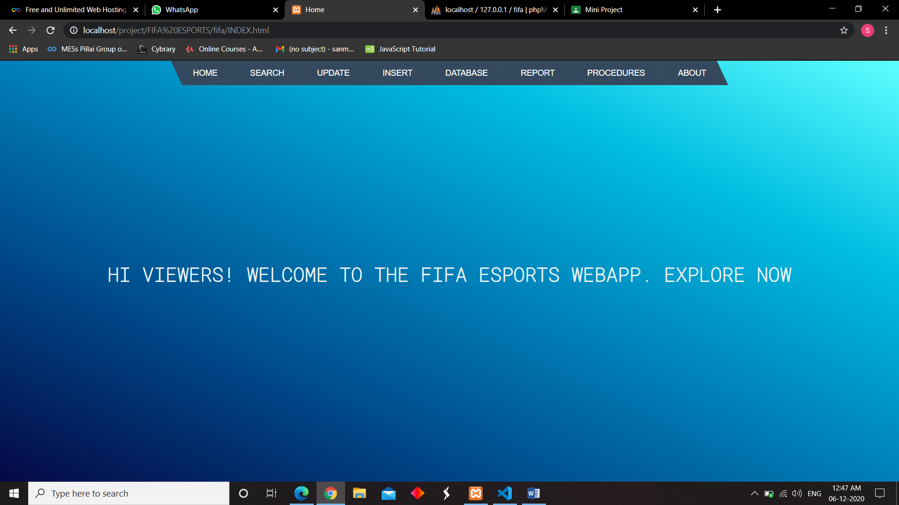

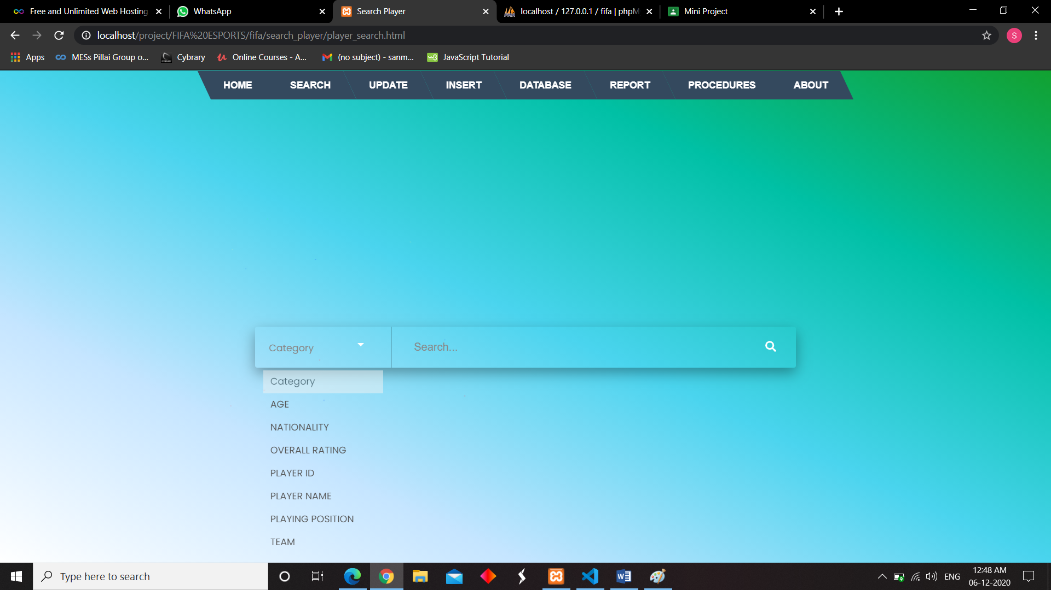

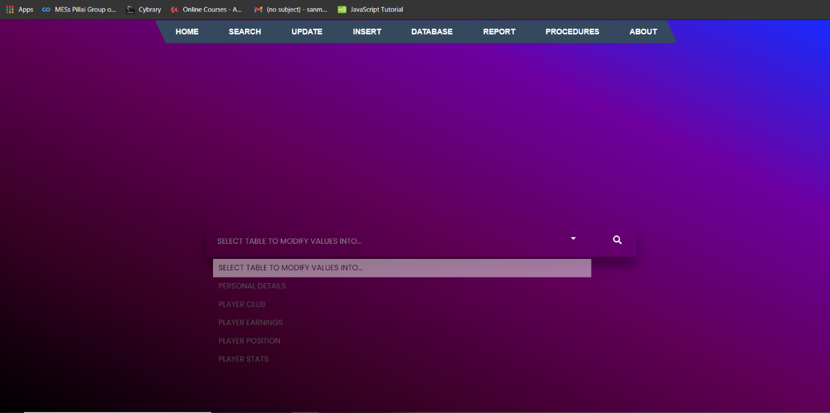

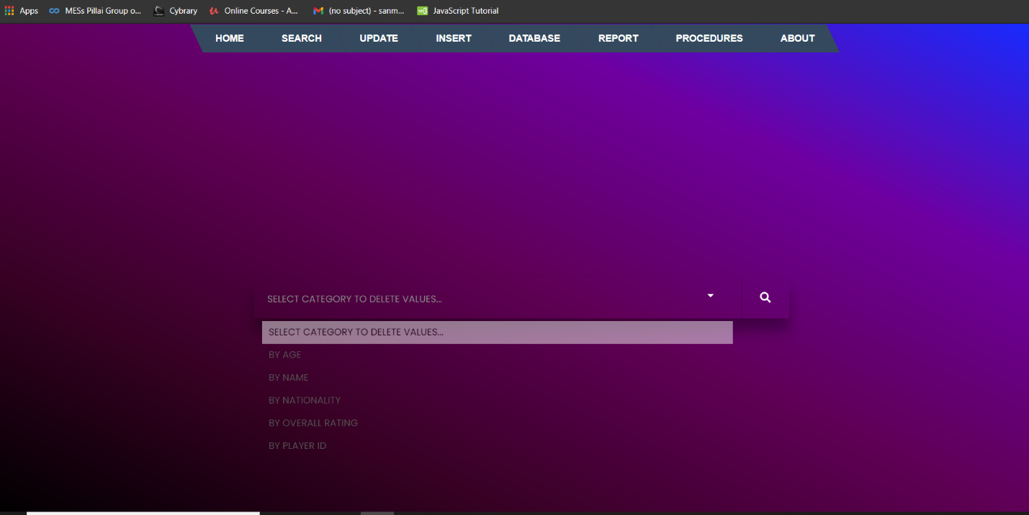

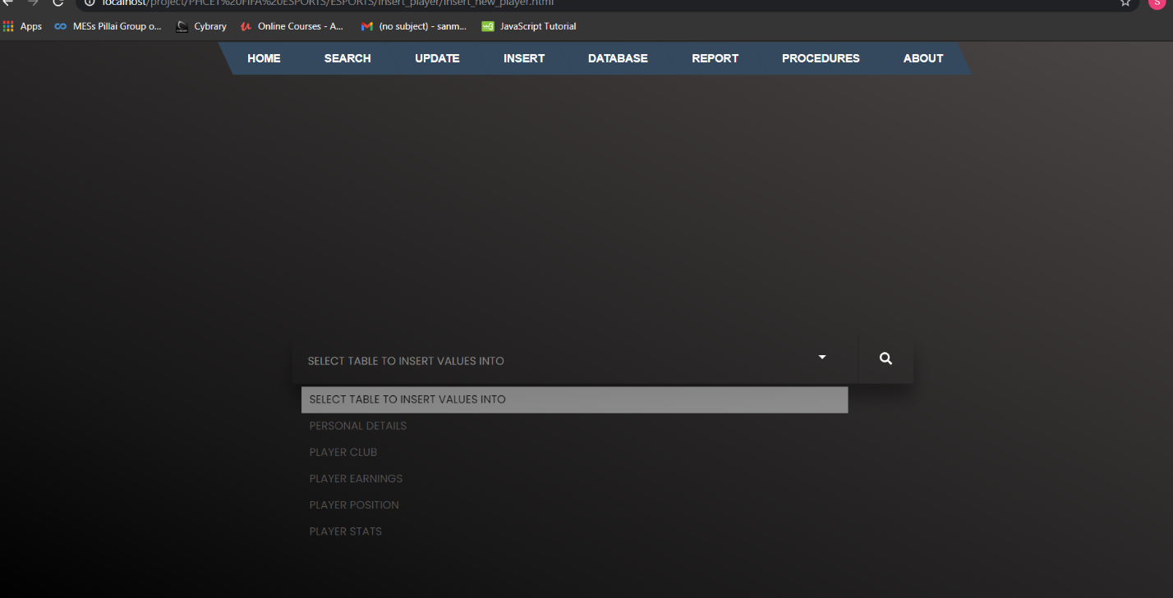

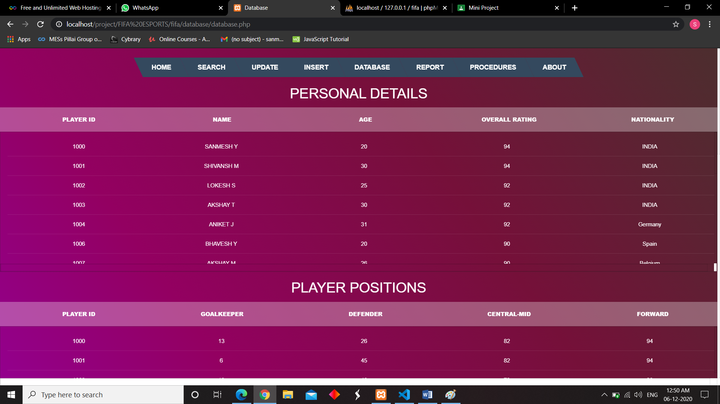

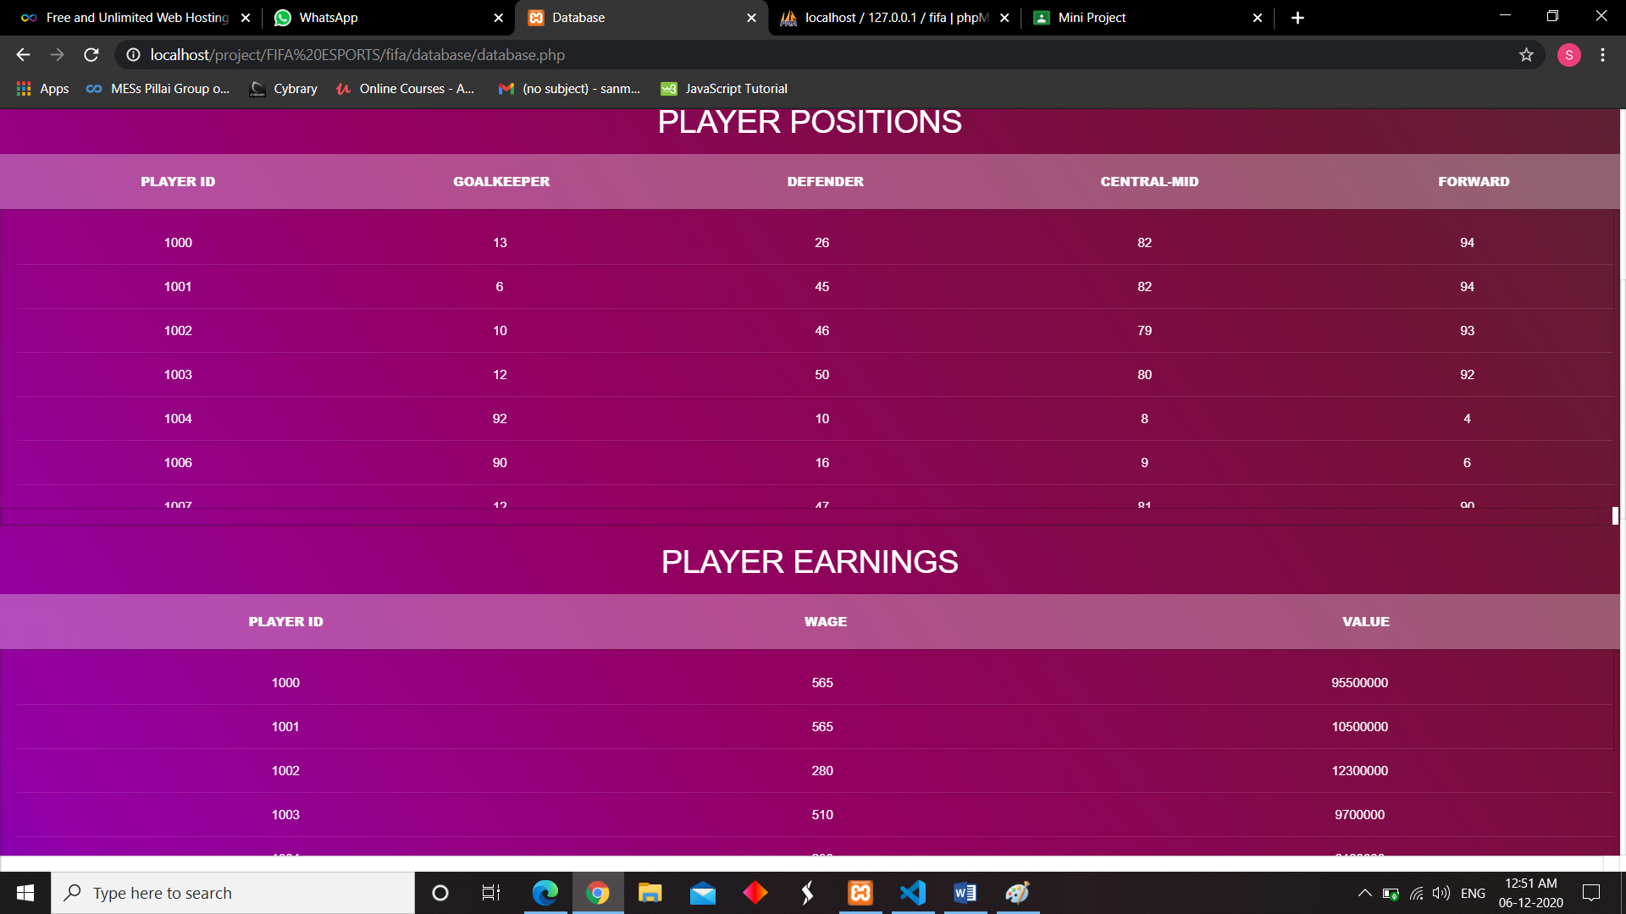

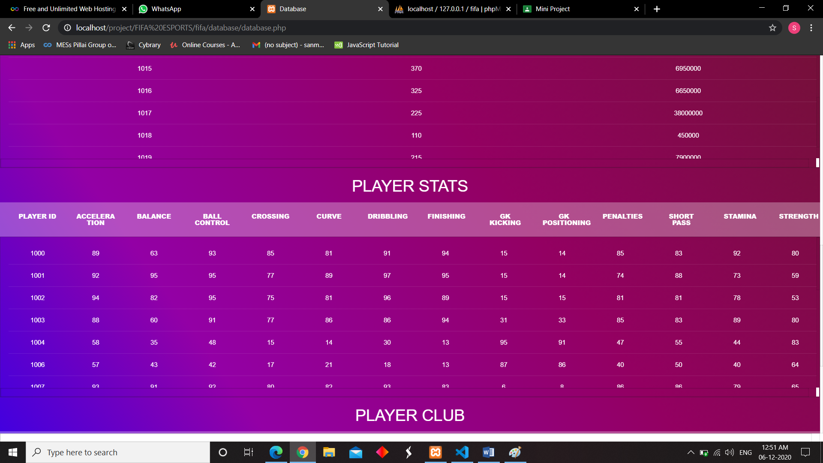

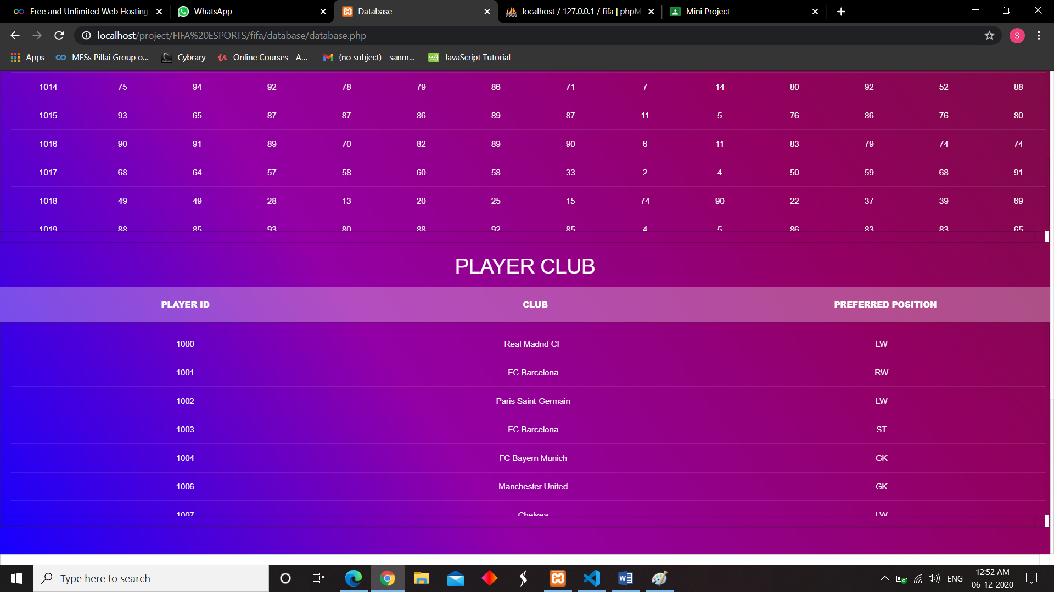

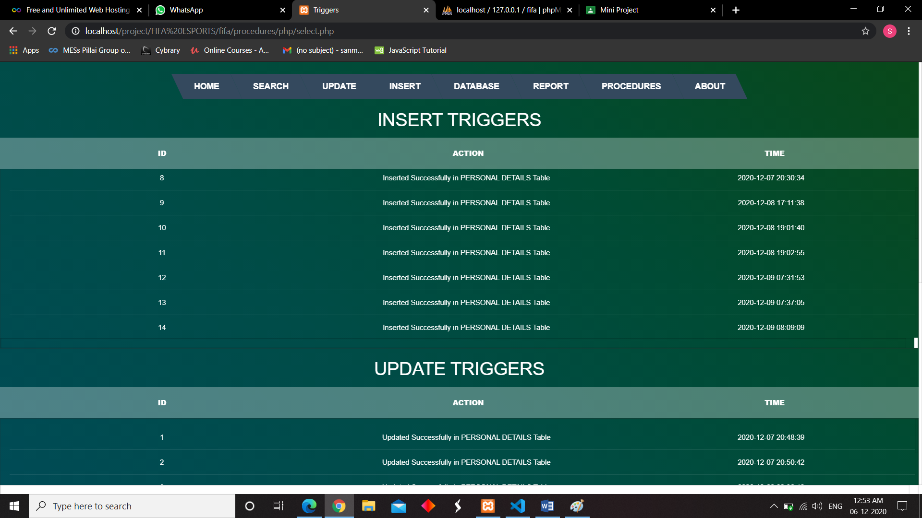

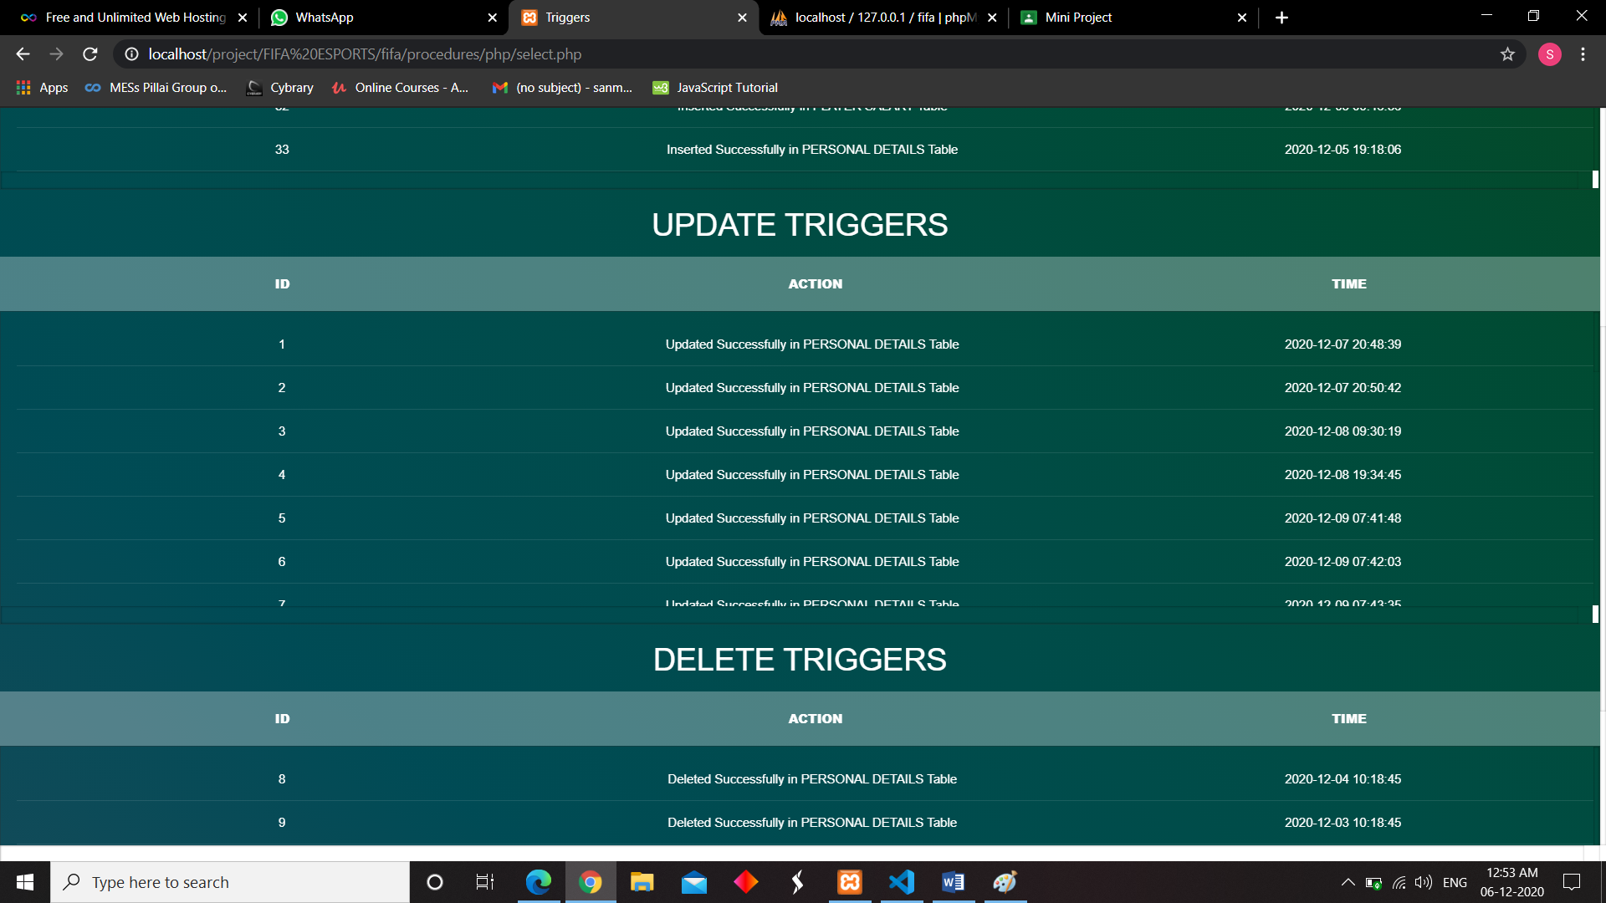

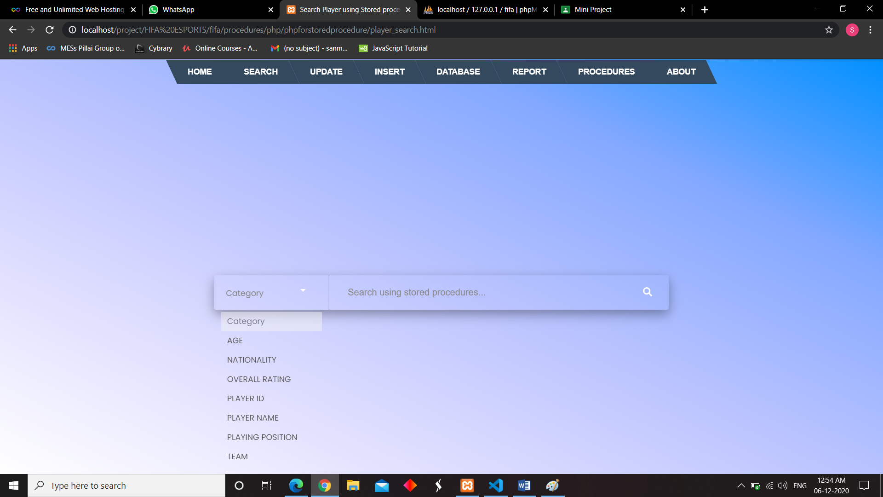

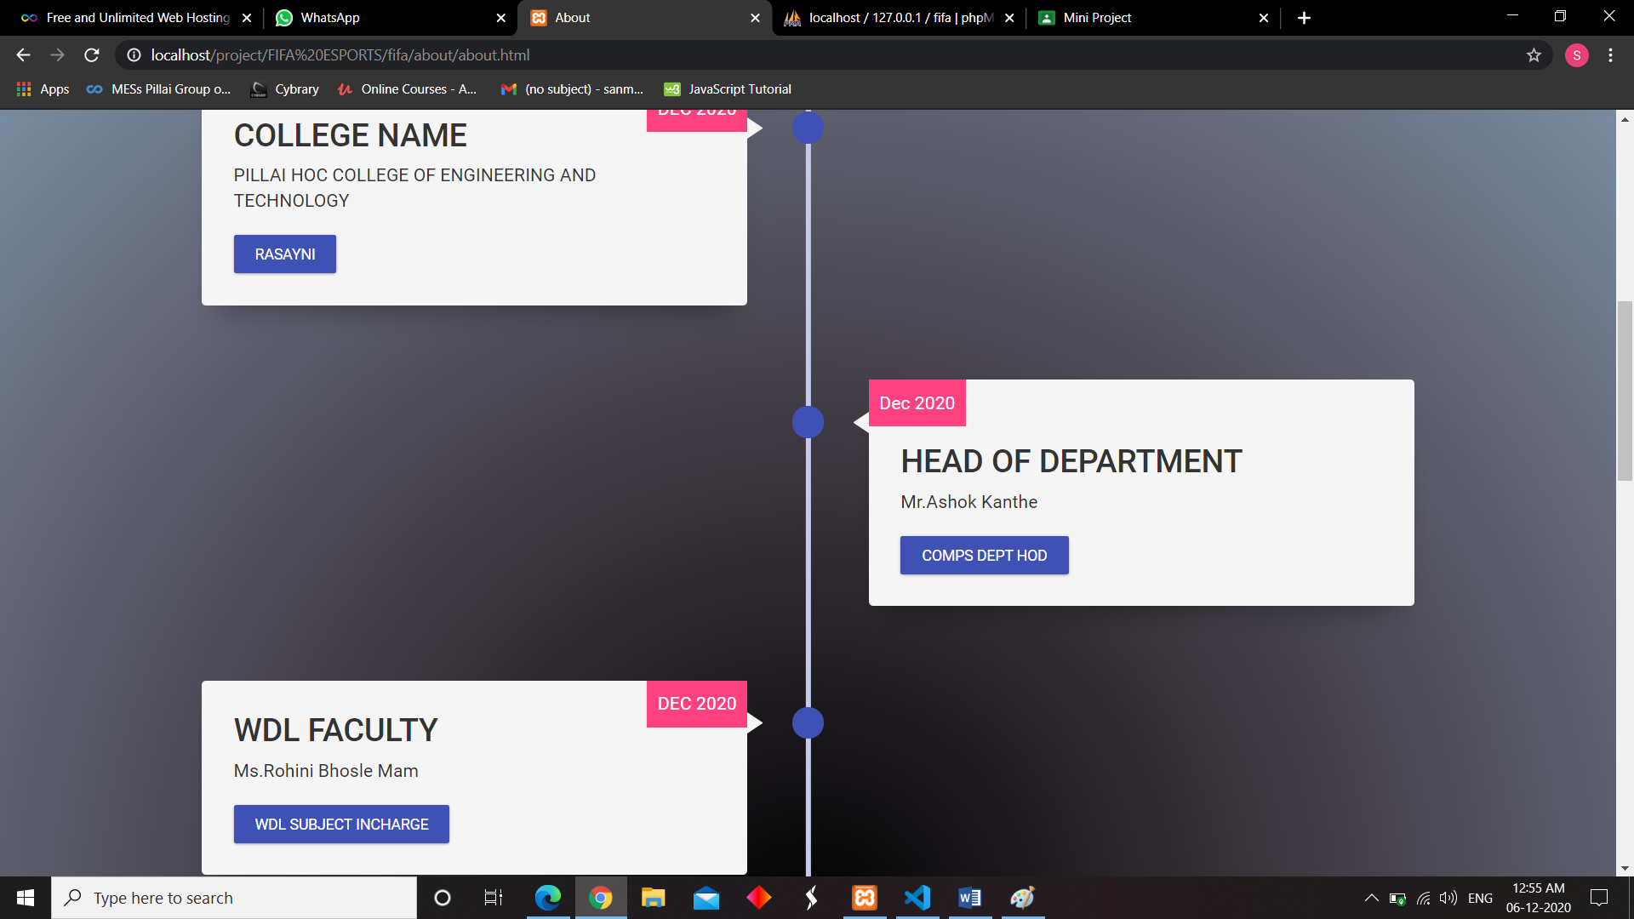

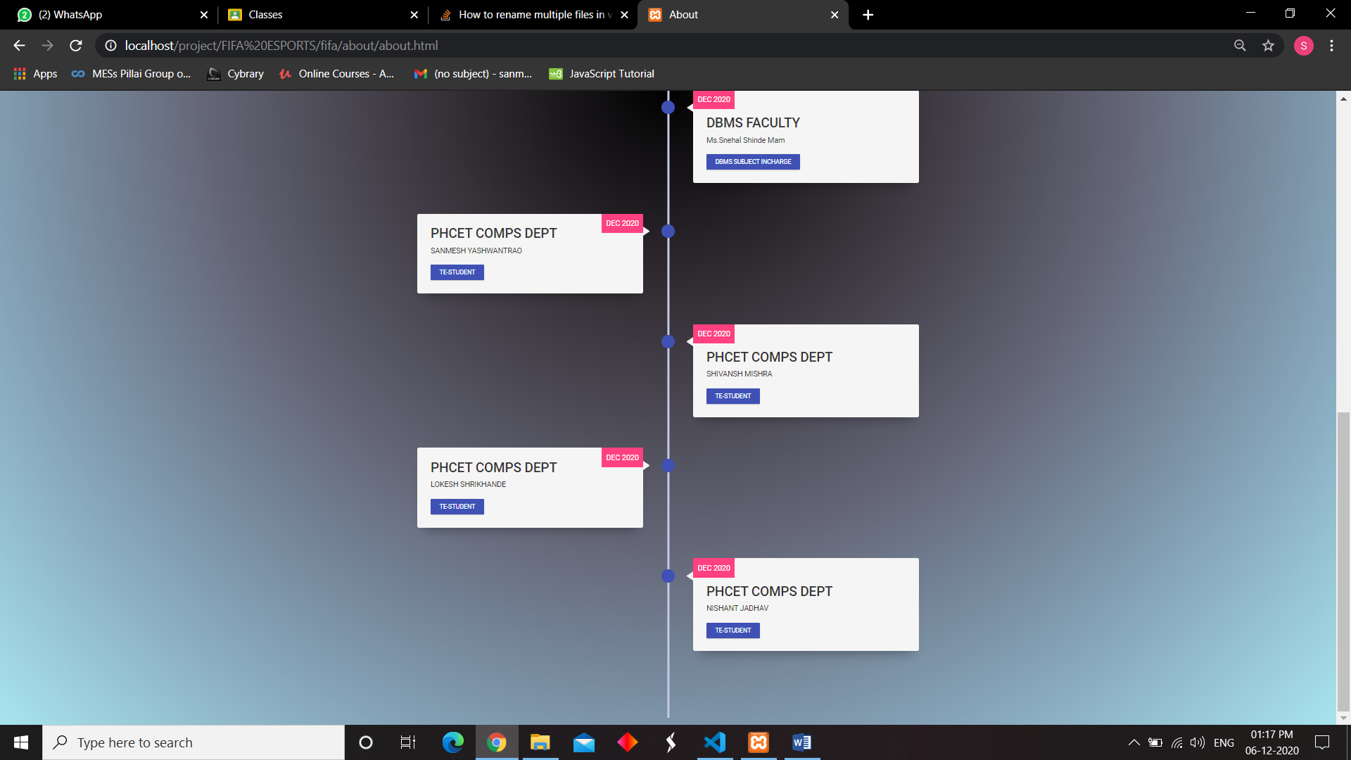

**4. Conclusion**

With FIFA E-SPORTS WEBAPP, an Institution or an esport gaming crew organization can maintain and store there players , trainies , coaches data as well as there statastics very easily with a FIFA E-SPORTS WEBAPP. It is also useful for institutions when the institution arrange there intra or inter college in door , outdoor competitons using FIFA E-SPORTS WEBAPP they can organize data of partcipants.

**5. Acknowledgement**

It is a privilege for us to have been associated with Ms. Rohini Bhosale , Ms Sneahk Shinde our guide, during this project work. We have been greatly benefited by her valuable suggestions and ideas. It is with great pleasure that we express our deep sense of gratitude to them for their valuable guidance, constant encouragement and patience throughout this work. I am also indebted to Dr. Ashok Kanthe (Head of Department of Computer Engineering), Ms. Rohini Bhosale( WDL Subject Incharge) , Ms. Snehal Shinde( DBMS Subject Incharge) for extending the help to academic literature.

We take this opportunity to thank all our classmates for their company during the course work and for useful discussion we had with them. We would be failing in our duties if we do not make a mention of our family members including our parents for providing moral support, without which this work would not have been completed.

**Submitted By:-**

Sanmesh Yashwantrao Shivnash Mishra

Lokesh Shrikhande Nishant Jadhav